MEDICAL INTERPRETER
TRAINING
MCA is pleased to announce that our Spanish/English medical interpreter course is now offered on-line.
This 80- hour course if offered over 16 weeks of individual study which includes a weekly 2- hour face to face session on line.
Training includes: a pre and post- test, midterm and final oral and written exams.
Participants will:
- Acquire a core knowledge and skills needed to handle advanced medical interpretation situations
- Learn how to organize and prioritize that knowledge needed for each medical encounter
- Acquire the knowledge of the national code of ethics and standards of practice and roles of the interpreter
- Acquire knowledge of note- taking and memory techniques.
- Learn about the role culture plays in interpreting
- Learn advanced anatomy and physiology in English and Spanish
- Participate in extensive role-play

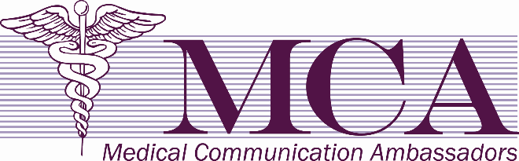
MCA’S MEDICAL INTERPRETERS COURSE IS ACCREDITED WITH DISTINCTION BY THE INTERNATIONAL MEDICAL INTERPRETER’S ASSOCIATION (IMIA)
ENHANCE YOUR RESUME WITH AN ACCREDITED TRAINING COURSE
- Interactive language proficiency testing
- Interpreter code of ethics/standards of practice
- Title VI, language access rights and HIPAA
- Body systems, terminology, diagnostics
- Health disparities
- Cultural competency
- Advice and personal narratives from a nationally certified interpreter
- Best techniques for effective interpretation
- Professional development
- Certificate of proficiency (upon passing the course)
- This course is designed for bilingual English/Spanish individuals who have a desire to learn how to be a professional medical interpreter.

Please contact us at
circe@mallofmagic.com
or visit our web-site at www.mcainterpreters.com
Cost is $1000.00 which includes all training materials, text and workbook and language proficiency exam. A $100.00 non-refundable deposit is required two weeks before starting class to cover your language proficiency exam conducted by a third party and to save your spot in the class. Payable by cash, money order or pay pal. To reserve your spot please call: 219-229-5351

